**CASE STUDY**

**Need for donations?**

One of the major positive effects of donating is simply feeling good about giving. Being able to give back to those in need helps you achieve a greater sense of personal satisfaction and growth, it feels good to help others. A donation may take various forms, including money, services, or goods such as clothing, toys, food, or vehicles.

**Problem:**

Children in orphanages cannot get the proper childhood and cannot get what needs in development like proper education, toys, and products for basic need

**Goal:**

The main goal is to provide a better living for those who cannot afford the goods to live a basic life better

**Solution:**

Spread awareness to people for the need of donations and provide a medium where they get to know the problem and help by providing them their basic amenities

**Contributors:**

Who: People who willing to spread happiness

What: Donations

Where: Ajmer (Local)

Why: Helping those and make their life better

**Profit Size:**

Zero profit, we don’t accept any transactions of money so no Burdon will come to you, we only take the goods which you don’t anymore and taking space at your home because the donations of goods you don’t need will help both of the side by helping you to manage those and giving someone a better **life.WORKING ENVIRONMENT**

* **Intel i3 processor**
* **Windows 10**
* **Microsoft word**
* **Google chrome**
* **Sublime text**

**PAGE DESCRIPTION& HTML CODE& CSS**

* **Web Page. HTML**

**Description:**

This is the landing page of our website which shows all the places that one can visit and allow the user to browse through all the various options we provide about donation.

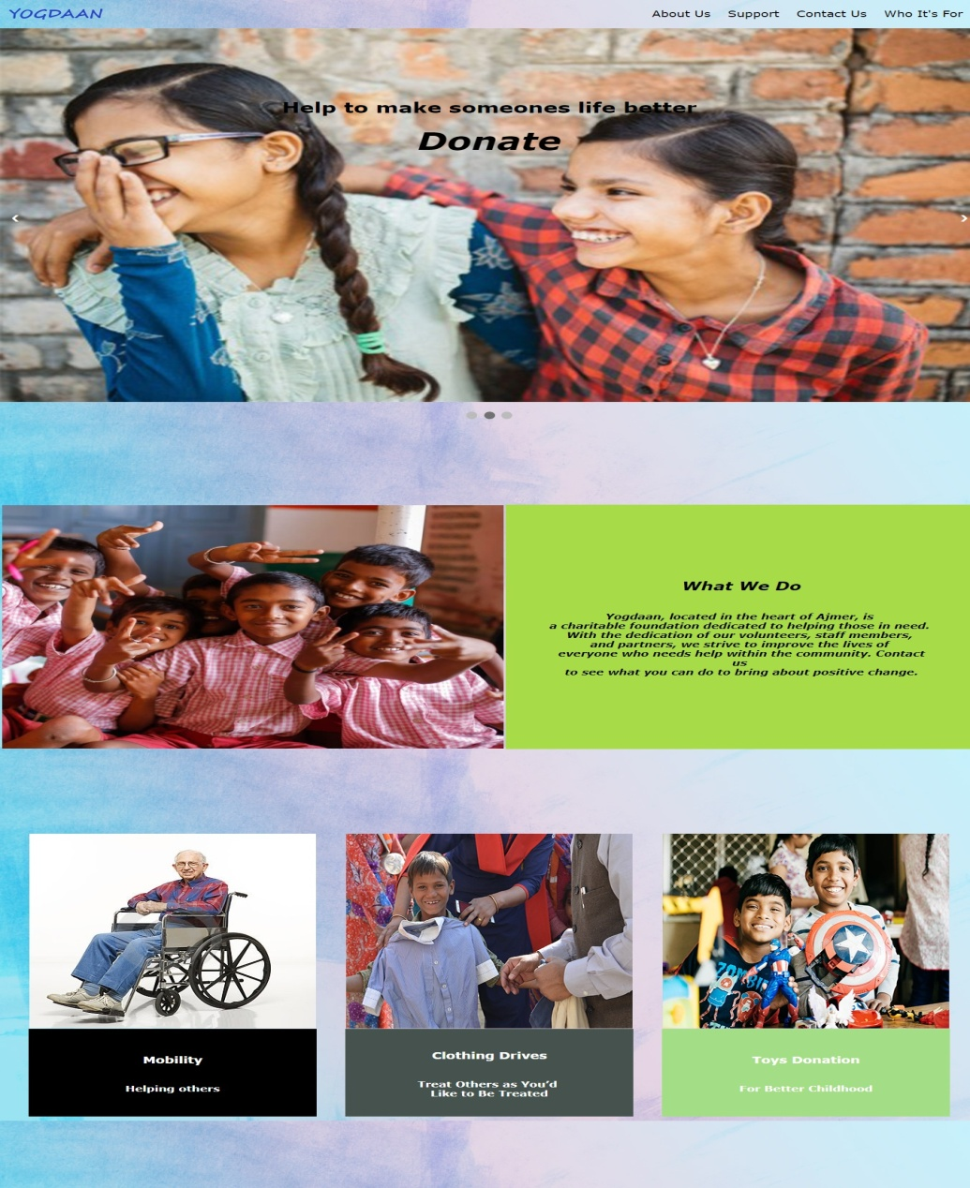

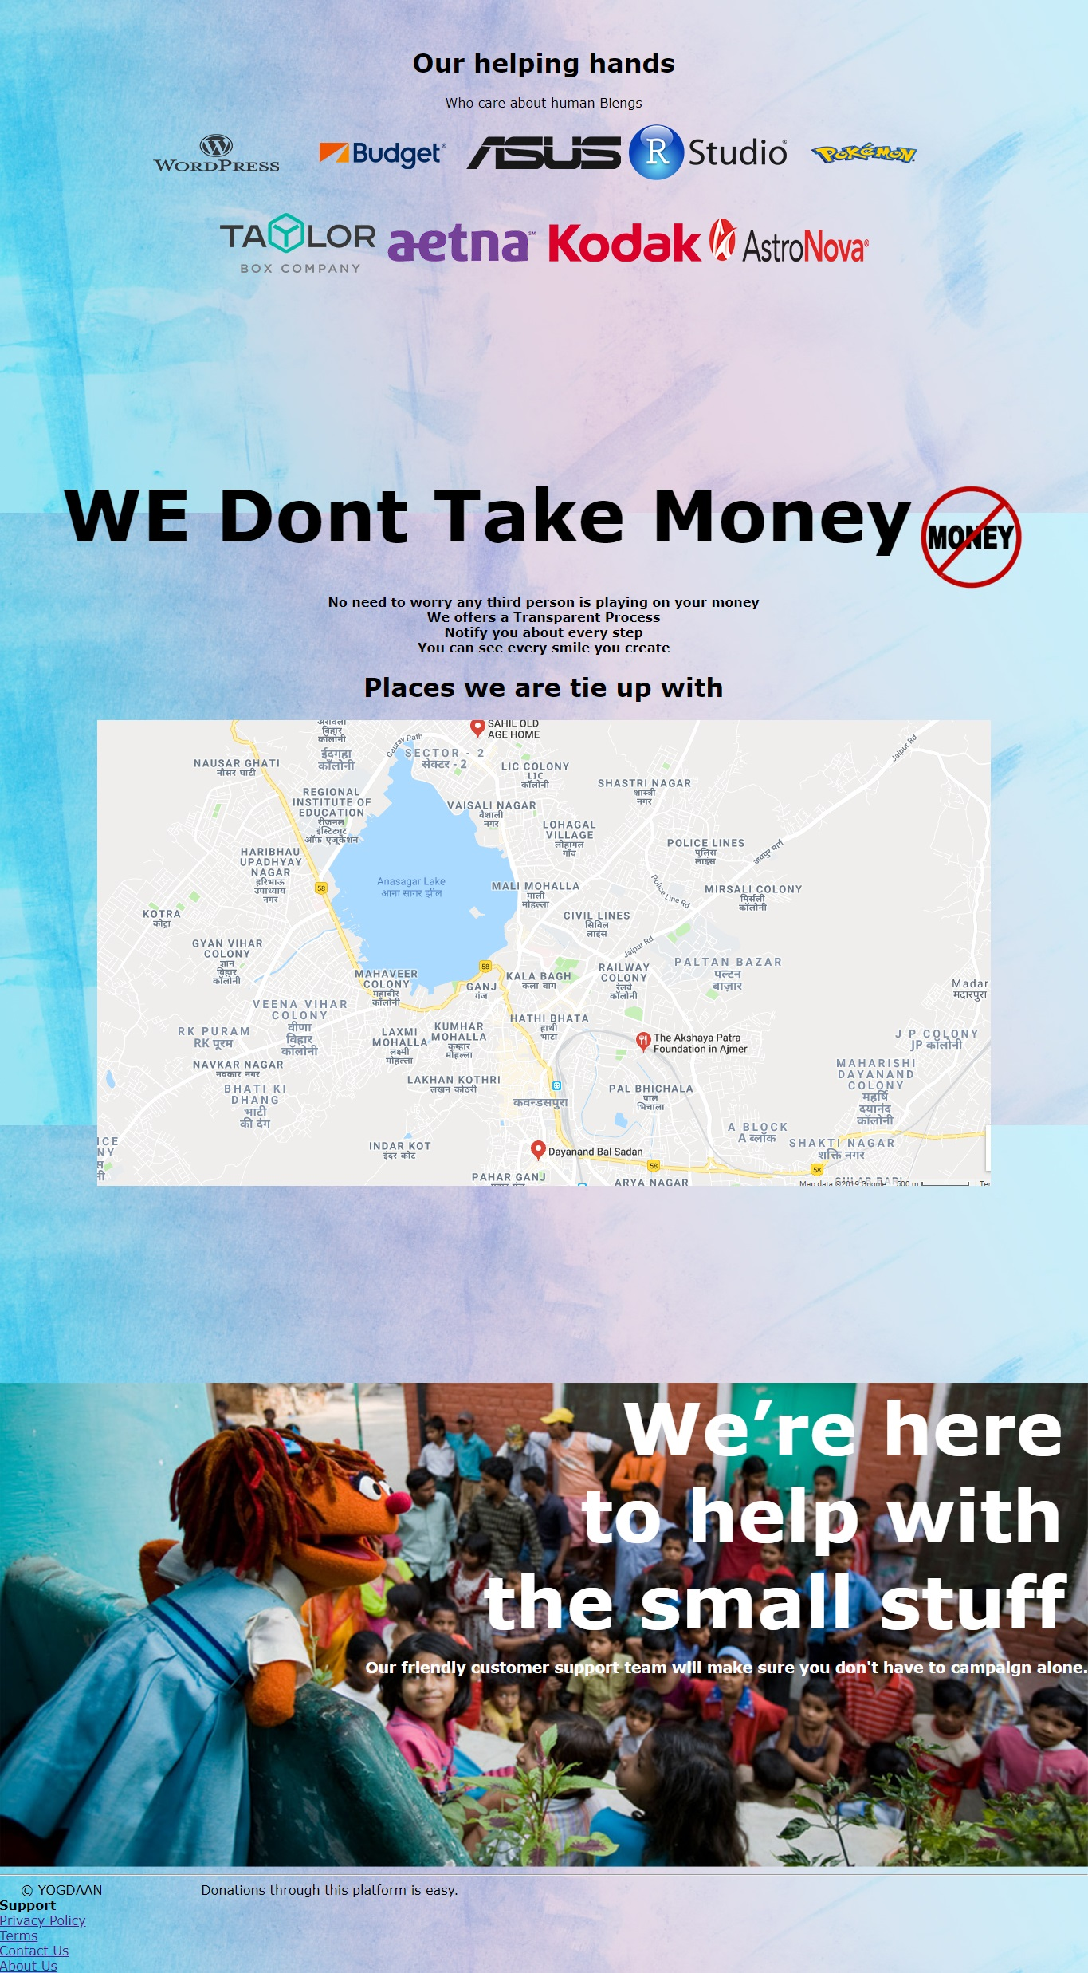

**Code:**

* Home

OCTYPE html>

<html>

<head>

<meta name="viewport" content="width=device-width, initial-scale=1">

<style>

* {

box-sizing: border-box;

}

body,

html {

height: 100%;

margin: 0;

font-family: Arial, Helvetica, sans-serif;

background-color: lightblue;

background-image: url("bg8.jpg");

}

.header {

overflow: hidden;

background-image: url("bg8.jpg");

/*background-color: lightblue;*/

padding: 5px 10px;

}

.header a {

float: left;

color: black;

text-align: center;

padding: 12px;

text-decoration: none;

font-size: 18px;

line-height: 25px;

border-radius: 4px;

}

.header a.logo {

font-size: 25px;

font-weight: bold;

background-image: url("yog.png");

background-repeat: no-repeat;

width: 140px;

/*background-size: cover;*/

background-position: center;

}

.header a:hover {

background-color: black;

color: white;

}

.header a.active {

background-color: #c1c1c1;

color: black;

}

.header-right {

float: right;

}

@media screen and (max-width: 500px) {

.header a {

float: none;

display: block;

text-align: left;

}

.header-right {

float: none;

}

}

.btn {

border: none;

color: white;

padding: 14px 28px;

cursor: pointer;

border-radius: 6px;

text-decoration: none;

}

.hver {

background-color: #4caf50;

}

.hver:hover {

background-color: #46a049;

}

.hero-image {

background-image: url("background.jpg");

height: 100%;

background-position: top;

background-repeat: no-repeat;

background-size: 100%;

position: relative;

}

.hero-text {

text-align: center;

position: absolute;

top: 50%;

left: 50%;

transform: translate(-50%, -50%);

color: black;

font-size: 25px;

text-shadow: 1px 1px #fff, -1px 1px #fff, 1px -1px #fff, -1px -1px #fff, 1px 1px 5px #555;

}

}

.headi {

text-align: center;

color: black;

font-size: 25px;

}

.spons {

background-image: url("logo.png");

background-repeat: no-repeat;

background-position: center;

}

.grey {

filter: grayscale(100%);

}

.imgg {

background-image: url("donate-banner.jpg");

height: 100%;

background-position: top;

background-repeat: no-repeat;

background-size: 100%;

position: relative;

}

.transbtn {

text-decoration: none;

border: none;

color: white;

padding: 14px 28px;

cursor: pointer;

border-radius: 6px;

}

.tex {

background-color: #ffffff00;

}

.tex:hover {

color: green;

}

.hero-text2 {

text-align: right;

font-size: 90px;

text-decoration: none;

}

.txt {

color: white;

}

.nomoney {

position: relative;

}

.thick {

font-size: 90px

}

.down {

transform: rotate(45deg);

-webkit-transform: rotate(45deg);

}

i {

border: solid black;

border-width: 0 3px 3px 0;

display: inline-block;

padding: 3px;

}

.link {

text-decoration: none;

padding-right: 30px;

}

* {

box-sizing: border-box

}

body {

font-family: Verdana, sans-serif;

margin: 0

}

.mySlides {

display: none

}

img {

vertical-align: middle;

}

/* Slideshow container */

.slideshow-container {

max-width: 100%;

position: relative;

margin: auto;

border-radius: 8px;

}

/* Next & previous buttons */

.prev,

.next {

cursor: pointer;

position: absolute;

top: 50%;

width: auto;

padding: 16px;

margin-top: -22px;

color: white;

font-weight: bold;

font-size: 18px;

transition: 0.6s ease;

border-radius: 0 3px 3px 0;

user-select: none;

}

/* Position the "next button" to the right */

.next {

right: 0;

border-radius: 3px 0 0 3px;

}

/* On hover, add a black background color with a little bit see-through */

.prev:hover,

.next:hover {

background-color: rgba(0, 0, 0, 0.8);

}

/* Caption text */

.text {

color: black;

font-size: 15px;

padding: 8px 12px;

position: absolute;

bottom: 500px;

width: 100%;

text-align: center;

}

/* The dots/bullets/indicators */

.dot {

cursor: pointer;

height: 15px;

width: 15px;

margin: 0 2px;

background-color: #bbb;

border-radius: 50%;

display: inline-block;

transition: background-color 0.6s ease;

}

.active,

.dot:hover {

background-color: #717171;

}

/* Fading animation */

.fade {

-webkit-animation-name: fade;

-webkit-animation-duration: 1.5s;

animation-name: fade;

animation-duration: 1.5s;

}

@-webkit-keyframes fade {

from {

opacity: .4

}

to {

opacity: 1

}

}

@keyframes fade {

from {

opacity: .4

}

to {

opacity: 1

}

}

/* On smaller screens, decrease text size */

@media only screen and (max-width: 300px) {

.prev,

.next,

.text {

font-size: 11px

}

}

.whatwedo {

height: 500px;

width: 700px;

}

.whatwedotext {

padding: 60px 60px;

background-color: #a8db48;

text-align: center;

font-style: oblique;

}

.td1 {

background-color: black;

}

.td2 {

background-color: #46524e;

}

.td3 {

background-color: #a3dd85;

}

.types {

color: white;

font-style: bold;

text-align: center;

}

.gfg {

border-collapse: separate;

border-spacing: 40px 0;

}

.gfg2 {

border-collapse: separate;

border-spacing: 10px 0;

/*background-color: black;*/

font-size: 50px;

font-weight: bolder;

text-decoration: none;

font-style: oblique;

color: black;

}

.gfg2:hover {

opacity: 0.5;

}

.capcol {

color: white;

}

</style>

</head>

<body>

<div class="header">

<a href="WEB PAGE.html" class="logo"> </a>

<div class="header-right">

<a href="about us.html">About Us</a>

<a href="#footer">Support</a>

<a href="Feedback.html">Feedbacks</a>

<a href="who its for.html">Who It's For</a>

</div>

</div>

<div class="slideshow-container">

<div class="mySlides fade">

<img src="slide1.jpg" style="width:100%">

<div class="text">

<h1>Help to make someones life better</h1>

<a class="gfg2" href="get started.html">Donate</a>

</div>

</div>

<div class="mySlides fade">

<img src="slide2.jpg" style="width:100%">

<div class="text">

<h1>Help to make someones life better</h1><a class="gfg2" href="get started.html">Donate</a></div>

</div>

<div class="mySlides fade">

<img src="slide3.jpg" style="width:100%">

<div class="text capcol">

<h1>Help to make someones life better</h1><a class="gfg2" href="get started.html">Donate</a></div>

</div>

<a class="prev" onclick="plusSlides(-1)">&#10094;</a>

<a class="next" onclick="plusSlides(1)">&#10095;</a>

</div>

<br>

<div style="text-align:center">

<span class="dot" onclick="currentSlide(1)"></span>

<span class="dot" onclick="currentSlide(2)"></span>

<span class="dot" onclick="currentSlide(3)"></span>

</div>

<script>

var slideIndex = 1;

showSlides(slideIndex);

function plusSlides(n) {

showSlides(slideIndex += n);

}

function currentSlide(n) {

showSlides(slideIndex = n);

}

function showSlides(n) {

var i;

var slides = document.getElementsByClassName("mySlides");

var dots = document.getElementsByClassName("dot");

if (n > slides.length) {

slideIndex = 1

}

if (n < 1) {

slideIndex = slides.length

}

for (i = 0; i < slides.length; i++) {

slides[i].style.display = "none";

}

for (i = 0; i < dots.length; i++) {

dots[i].className = dots[i].className.replace(" active", "");

}

slides[slideIndex - 1].style.display = "block";

dots[slideIndex - 1].className += " active";

}

</script>

<table align="center">

<tr>

<td><img src="background3.jpg" class="whatwedo"></td>

<td class="whatwedotext">

<p>

<h2>What We Do</h2>

<br><b>Yogdaan, located in the heart of Ajmer, is <br> a charitable foundation dedicated to helping those in need. <br> With the dedication of our volunteers, staff members, <br> and partners, we strive to improve the lives of <br> everyone who needs help within the community. Contact us <br> to see what you can do to bring about positive change.</b></p>

</td>

</tr>

</table>

<table align="center" class="gfg">

<tr>

<th><img src="old.jpg"></th>

<th><img src="old2.jpg"></th>

<th><img src="old3.jpg"></th>

</tr>

<tr class="types">

<td class="td1">

<h3><br>Mobility</h3>

<br><b>Helping others</b>

</td>

<td class="td2">

<h3><br>Clothing Drives</h3>

<br><b>Treat Others as You’d <br>Like to Be Treated</b>

</td>

<td class="td3">

<h3><br>Toys Donation</h3>

<br><b>For Better Childhood</b>

<br>

<br>

<br>

</td>

</tr>

</table>

<div align="center">

<h1 class="headi">Our helping hands</h1>

<p class="headi">Who care about human Biengs</p>

</div>

<div align="center">

<img src="co1.png"><b></b>

<img src="co2.png"><b></b>

<img src="co3.png"><b></b>

<img src="co4.png"><b></b>

<img src="co5.png">

<br>

<br>

<br>

<img src="co6.png"><b></b>

<img src="co7.png"><b></b>

<img src="co8.png"><b></b>

<img src="co9.png"><b></b>

</div>

<div class="nomoney" align="center">

<font class="thick"><strong>WE Dont Take Money</strong></font>

<img src="nomoney.png" height="10%" width="10%">

<br>

<b>No need to worry any third person is playing on your money</b>

<br>

<b>We offers a Transparent Process</b>

<br>

<b>Notify you about every step</b>

<br>

<b>You can see every smile you create</b>

</div>

<div align="center">

<h1>Places we are tie up with</h1>

<img src="map.png">

<br>

<!-- <div align="left">

<ol>

<h1><li>Dayanand Bal Sadan</h1></li>

<ul>

<li><a href="http://dayanandbalsadan.com/"><b>Website</b></a></li>

<li>0145 246 1684</li>

</ul>

<h1><li>SAHIL OLD AGE HOME</li></h1>

<ul>

<li><a href="http://sahiloldagehome.com/"><b>Website</b></a></li>

<li>099283 91172</li>

</ul>

<h1><li>The Akshaya Patra Foundation in Ajmer</li></h1>

<ul>

<li><a href="https://rajasthan.akshayapatra.org/"><b>Website</b></a></li>

<li>1800 425 8622</li>

</ul>

</ol>

</div> -->

</div>

<br>

<div class="imgg">

<div class="hero-text2">

<a href="WEB PAGE.html" class="transbtn tex"><b>We’re here <br> to help with <br> the small stuff</b></a>

</div>

<h3 align="right" class="txt">Our friendly customer support team will make sure you don't have to campaign alone.</h3>

</div>

<hr>

<span style="padding-left:2%;padding-bottom:2%;">&copy; YOGDAAN &nbsp&nbsp&nbsp&nbsp&nbsp&nbsp&nbsp&nbsp&nbsp&nbsp&nbsp&nbsp&nbsp&nbsp&nbsp&nbsp&nbsp&nbsp&nbsp&nbsp&nbspDonations through this platform is easy.</span>

<br>

<b>Support</b>

<br>

<a href="privacy policy.html">Privacy Policy</a>

<br>

<a href="terms.html">Terms</a>

<br>

<a href=" Feedback.html"> Feedback </a>

<br>

<a href="about us.html">About Us</a>

<br>

<footer id="footer"></footer>

</body>

</html>

* **About Us.html**

**Description:**

In this you will find the details about our website that we work who are we and what we do.

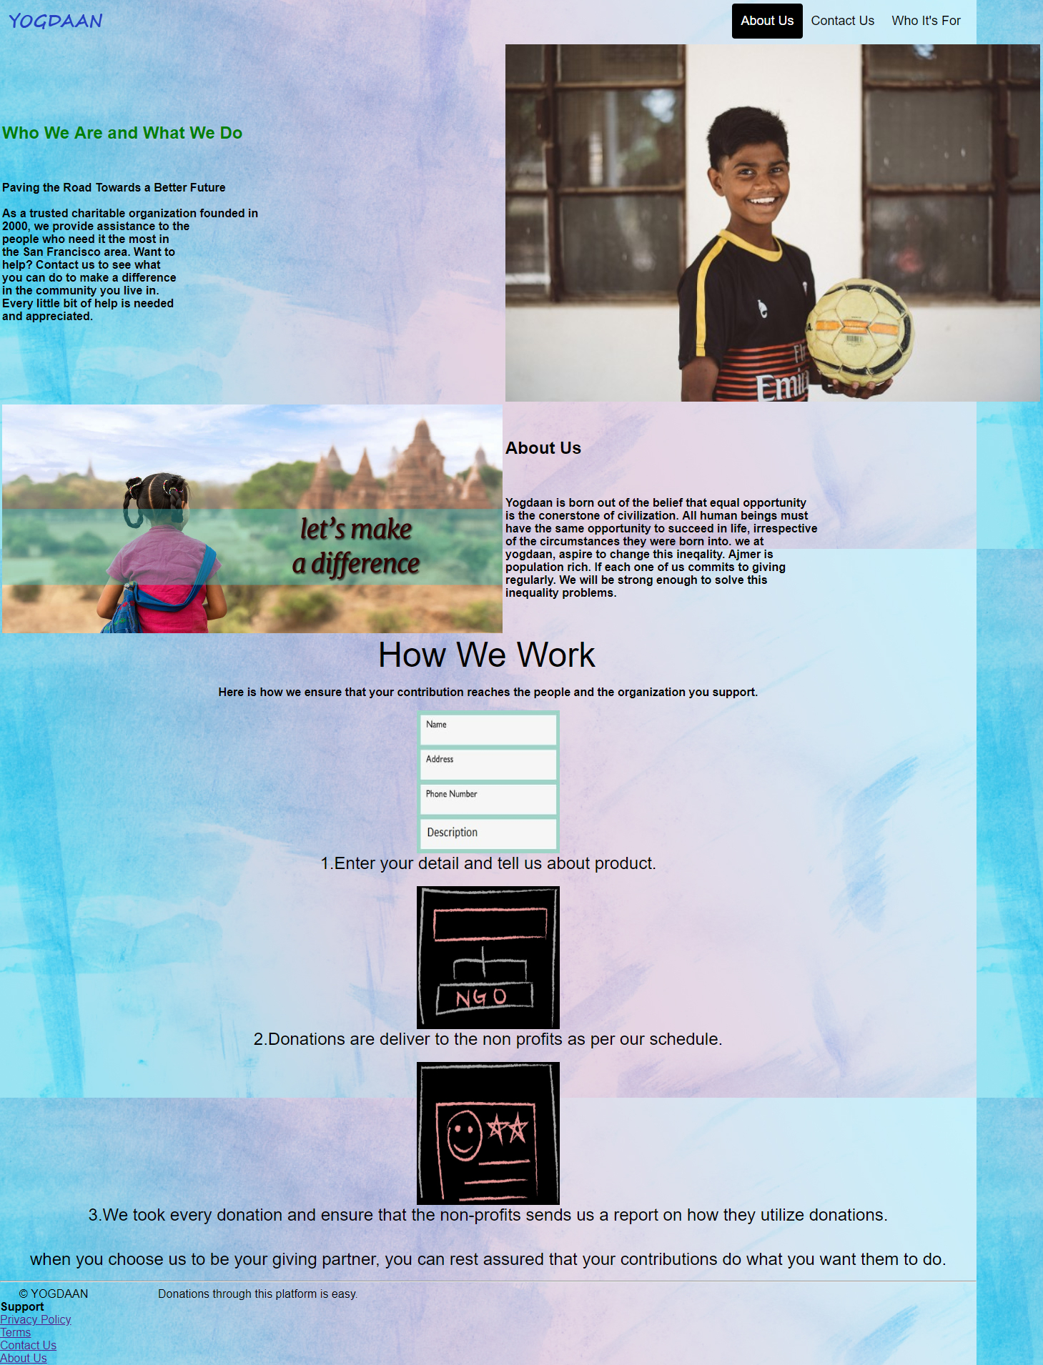

**Code:**

* HTML

<html>

<head>

<style type="text/css">

* {

box-sizing: border-box;

}

body,

html {

height: 100%;

margin: 0;

font-family: Arial, Helvetica, sans-serif;

background-color: lightblue;

background-image: url("bg8.jpg");

}

.header {

overflow: hidden;

background-image: url("bg8.jpg");

/*background-color: lightblue;*/

padding: 5px 10px;

}

.header a {

float: left;

color: black;

text-align: center;

padding: 12px;

text-decoration: none;

font-size: 18px;

line-height: 25px;

border-radius: 4px;

}

.header a.logo {

font-size: 25px;

font-weight: bold;

background-image: url("yog.png");

background-repeat: no-repeat;

width: 140px;

/*background-size: cover;*/

background-position: center;

}

.header a:hover {

background-color: black;

color: white;

}

.header a.active {

background-color: black;

color: white;

}

.header-right {

float: right;

}

.link {

text-decoration: none;

padding-right: 30px;

}

.header-center {

text-align: center;

text-shadow: 0.7px 0.7px #fff, -0.7px 0.7px #fff, 0.7px -0.7px #fff, -0.7px -0.7px #fff, 0.7px 0.7px 5px #555;

}

.hero-image {

background-image: url("child.jpg");

background-color: #cccccc;

height: 500px;

background-position: center;

background-repeat: no-repeat;

background-size: cover;

position: relative;

}

}

.texta {

text-align: center;

font-style: oblique;

}

.whowe {

color: green;

}

</style>

</head>

<body>

<div class="header">

<a href="WEB PAGE.html" class="logo"> </a>

<div class="header-right">

<a href="about us.html" class="active">About Us</a>

<a href="Feedback.html">Feedback</a>

<a href="who its for.html">Who It's For</a>

</div>

</div>

<table align="center">

<tr>

<td class="texta">

<h2 class="whowe">Who We Are and What We Do</h2>

<br>

<p><b>Paving the Road Towards a Better Future <br><br> As a trusted charitable organization founded in <br>2000, we provide assistance to the <br> people who need it the most in <br>the San Francisco area. Want to <br>help? Contact us to see what <br>you can do to make a difference <br>in the community you live in. <br>Every little bit of help is needed <br>and appreciated.</b></p>

</td>

<td><img src="child5.jpg" height="500px"></td>

</tr>

<tr>

<td class="texta"><img src="child6.jpg" width="700px"></td>

<td>

<h2>About Us</h2>

<br>

<p><b>Yogdaan is born out of the belief that equal opportunity <br>is the conerstone of civilization. All human beings must<br> have the same opportunity to succeed in life, irrespective<br> of the circumstances they were born into. we at<br> yogdaan, aspire to change this ineqality. Ajmer is<br> population rich. If each one of us commits to giving<br> regularly. We will be strong enough to solve this<br> inequality problems.

</b></p>

</td>

</tr>

</table>

<div align="center">

<font color="black" size="20">How We Work</font>

<br>

<p><b>Here is how we ensure that your contribution reaches the people and the organization you support.</b></p>

<img src="step1.jpeg" height="200" width="200">

<br>

<font color="black" size="5">1.Enter your detail and tell us about product.</font>

<br>

<br>

<img src="step2.jpg" height="200" width="200">

<br>

<font color="black" size="5">2.Donations are deliver to the non profits as per our schedule.</font>

<br>

<br>

<img src="step3.jpg" height="200" width="200">

<br>

<font color="black" size="5">3.We took every donation and ensure that the non-profits sends us a report on how they utilize donations.</font>

<br>

<br>

<!-- <img src="step4.png" height="200" width="200"><br> -->

<p> <font size="5%">when you choose us to be your giving partner, you can rest assured that your contributions do what you want them to do.</font></p>

</div>

</div>

<hr>

<span style="padding-left:2%;padding-bottom:2%;">&copy; YOGDAAN &nbsp&nbsp&nbsp&nbsp&nbsp&nbsp&nbsp&nbsp&nbsp&nbsp&nbsp&nbsp&nbsp&nbsp&nbsp&nbsp&nbsp&nbsp&nbsp&nbsp&nbspDonations through this platform is easy.</span>

<br>

<b>Support</b>

<br>

<a href="privacy policy.html">Privacy Policy</a>

<br>

<a href="terms.html">Terms</a>

<br>

<a href=" Feedback.html"> Feedback </a>

<br>

<a href="about us.html">About Us</a>

<br>

<footer id="footer"></footer>

</div>

</body>

</html>

* **Feedback**

**Descrption:**

It allows user to ask queries and to contact us on our feeds.

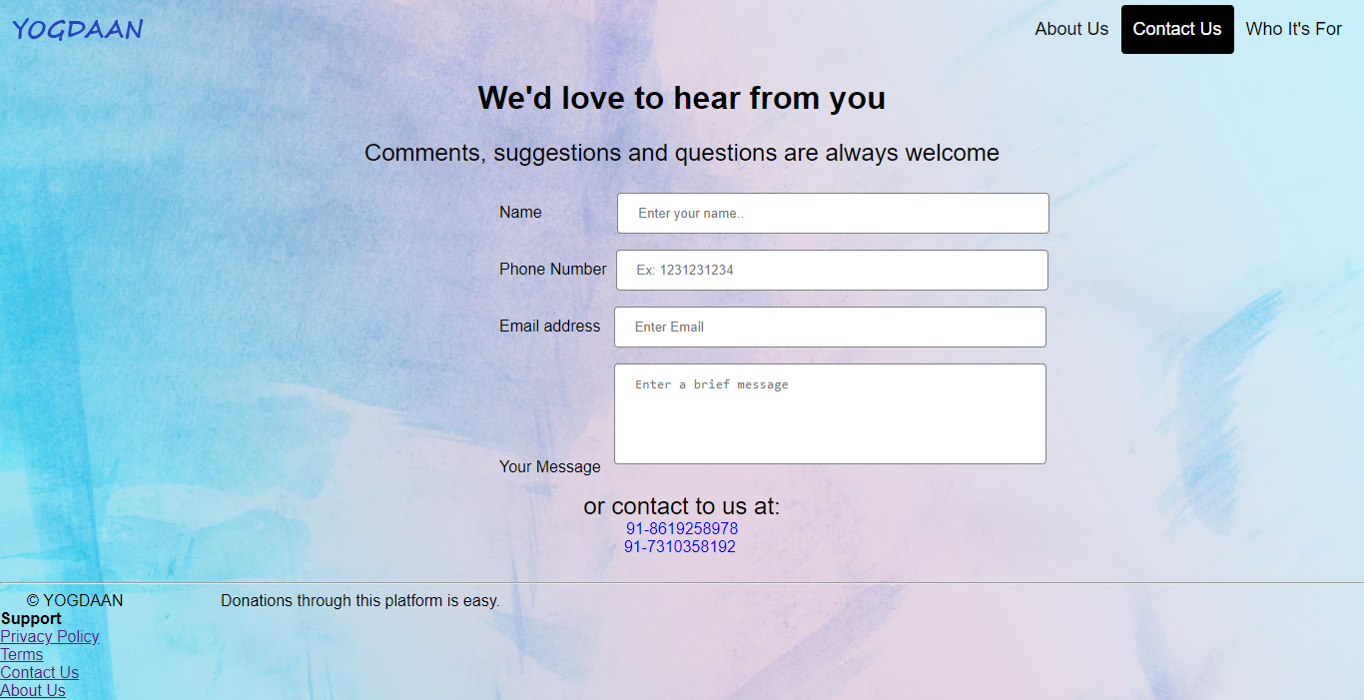

**Code:**

* HTML

<html>

<head>

<style type="text/css">

* {

box-sizing: border-box;

}

body,

html {

height: 100%;

margin: 0;

font-family: Arial, Helvetica, sans-serif;

background-color: lightblue;

background-image: url("bg8.jpg");

}

.header {

overflow: hidden;

background-image: url("bg8.jpg");

/*background-color: lightblue;*/

padding: 5px 10px;

}

.header a {

float: left;

color: black;

text-align: center;

padding: 12px;

text-decoration: none;

font-size: 18px;

line-height: 25px;

border-radius: 4px;

}

.header a.logo {

font-size: 25px;

font-weight: bold;

background-image: url("yog.png");

background-repeat: no-repeat;

width: 140px;

/*background-size: cover;*/

background-position: center;

}

.header a:hover {

background-color: black;

color: white;

}

.header a.active {

background-color: black;

color: white;

}

.header-right {

float: right;

}

.inps {

width: 50%;

background-color: grey;

color: white;

padding: 14px 20px;

margin: 8px 0;

border: none;

border-radius: 4px;

cursor: pointer;

}

.inp {

width: 50%;

padding: 12px 20px;

margin: 8px 0;

display: inline-block;

border: 1px solid grey;

border-radius: 4px;

box-sizing: border-box;

resize: none;

}

.mrg {

text-align: left;

margin-left: 500px;

}

input[type=submit]:hover {

background-color: grey;

}

.header-center {

text-align: center;

}

.link {

text-decoration: none;

padding-right: 30px;

}

</style>

</head>

<body>

<div class="header">

<a href="WEB PAGE.html" class="logo"> </a>

<div class="header-right">

<a href="about us.html">About Us</a>

<a href="Feedback.html" class="active">Feedback </a>

<a href="who its for.html">Who It's For</a>

</div>

</div>

<div class="header-center">

<h1>We'd love to hear from you</h1>

<font size="5">Comments, suggestions and questions are always welcome</font>

<br>

<br>

<form class="mrg">

<div class="form-group">

<label for="contact-name">Name &nbsp &nbsp &nbsp &nbsp &nbsp &nbsp &nbsp &nbsp</label>

<input type="text" class="form-control inp" id="contact-name" name="name" placeholder="Enter your name.." onkeyup='validateName()'>

<span class='error-message' id='name-error'></span>

</div>

<div class="form-group">

<label for="contact-phone">Phone Number&nbsp</label>

<input type="tel" class="form-control inp" id="contact-phone" name="phone" placeholder="Ex: 1231231234" onkeyup='validatePhone()'>

<span class='error-message' id='phone-error'></span>

</div>

<div class="form-group">

<label for="contact-email">Email address&nbsp&nbsp</label>

<input type="email" class="form-control inp" id="contact-email" name="email" placeholder="Enter Email" onkeyup='validateEmail()'>

<span class='error-message' id='email-error'></span>

</div>

<div class="form-group">

<label for='contactMessage'>Your Message &nbsp</label>

<textarea class="form-control inp" rows="5" id='contact-message' name='message' placeholder="Enter a brief message" onkeyup='validateMessage()'></textarea>

<span class='error-message' id='message-error'></span>

</div>

</form>

<font size="5">or contact to us at:<br></font>

<font color="blue">91-8619258978</font>

<br>

<font color="blue"> 91-7310358192</font>

<br>

<br>

</div>

<script type="text/javascript">

function validateName() {

var name = document.getElementById('contact-name').value;

if (name.length == 0) {

producePrompt('Name is required', 'name-error', 'red')

return false;

}

if (!name.match(/^[A-Za-z]*\s{1}[A-Za-z]*$/)) {

producePrompt('First and last name, please.', 'name-error', 'red');

return false;

}

producePrompt('Valid', 'name-error', 'green');

return true;

}

function validatePhone() {

var phone = document.getElementById('contact-phone').value;

if (phone.length == 0) {

producePrompt('Phone number is required.', 'phone-error', 'red');

return false;

}

if (phone.length != 10) {

producePrompt('Not Valid.', 'phone-error', 'red');

return false;

}

if (!phone.match(/^[0-9]{10}$/)) {

producePrompt('Only digits, please.', 'phone-error', 'red');

return false;

}

producePrompt('Valid', 'phone-error', 'green');

return true;

}

function validateEmail() {

var email = document.getElementById('contact-email').value;

if (email.length == 0) {

producePrompt('Email Invalid', 'email-error', 'red');

return false;

}

if (!email.match(/^\w+([\.-]?\w+)*\w+([\.-]?)@\w+([\.-]?\w+)*(\.\w{2,3})+$/)) {

producePrompt('Email Invalid', 'email-error', 'red');

return false;

}

producePrompt('Valid', 'email-error', 'green');

return true;

}

function validateMessage() {

var message = document.getElementById('contact-message').value;

var required = 30;

var left = required - message.length;

if (left > 0) {

producePrompt(left + ' more characters required', 'message-error', 'red');

return false;

}

producePrompt('Valid', 'message-error', 'green');

return true;

}

function validateForm() {

if (!validateName() || !validatePhone() || !validateEmail() || !validateMessage()) {

jsShow('submit-error');

producePrompt('Please fix errors to submit.', 'submit-error', 'red');

setTimeout(function() {

jsHide('submit-error');

}, 2000);

} else {

}

}

function jsShow(id) {

document.getElementById(id).style.display = 'block';

}

function jsHide(id) {

document.getElementById(id).style.display = 'none';

}

function producePrompt(message, promptLocation, color) {

document.getElementById(promptLocation).innerHTML = message;

document.getElementById(promptLocation).style.color = color;

}

</script>

<script>

var selDiv = "";

document.addEventListener("DOMContentLoaded", init, false);

function init() {

document.querySelector('#files').addEventListener('change', handleFileSelect, false);

selDiv = document.querySelector("#selectedFiles");

}

function handleFileSelect(e) {

if (!e.target.files || !window.FileReader) return;

selDiv.innerHTML = "";

var files = e.target.files;

var filesArr = Array.prototype.slice.call(files);

filesArr.forEach(function(f) {

var f = files[i];

if (!f.type.match("image.*")) {

return;

}

var reader = new FileReader();

reader.onload = function(e) {

var html = "<img src=\"" + e.target.result + "\">" + f.name + "<br clear=\"left\"/>";

selDiv.innerHTML += html;

}

reader.readAsDataURL(f);

});

}

</script>

<hr>

<span style="padding-left:2%;padding-bottom:2%;">&copy; YOGDAAN &nbsp&nbsp&nbsp&nbsp&nbsp&nbsp&nbsp&nbsp&nbsp&nbsp&nbsp&nbsp&nbsp&nbsp&nbsp&nbsp&nbsp&nbsp&nbsp&nbsp&nbspDonations through this platform is easy.</span>

<br>

<b>Support</b>

<br>

<a href="privacy policy.html">Privacy Policy</a>

<br>

<a href="terms.html">Terms</a>

<br>

<a href=" Feedback.html"> Feedback </a>

<br>

<a href="about us.html">About Us</a>

<br>

<footer id="footer"></footer>

</body>

</html>

* **Who It’s for**

In this,we told about who this website for-the people who are poor and need some attention.

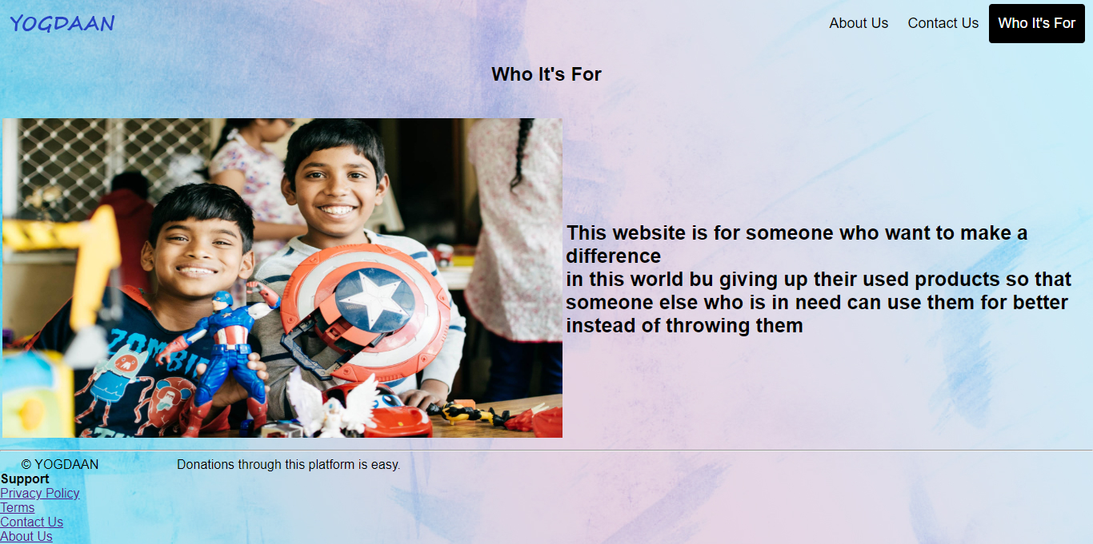

<!DOCTYPE html>

<html>

<head>

<meta name="viewport" content="width=device-width, initial-scale=1">

<style>

* {

box-sizing: border-box;

}

body,

html {

height: 100%;

margin: 0;

font-family: Arial, Helvetica, sans-serif;

background-color: lightblue;

background-image: url("bg8.jpg");

}

.header {

overflow: hidden;

background-image: url("bg8.jpg");

/*background-color: lightblue;*/

padding: 5px 10px;

}

.header a {

float: left;

color: black;

text-align: center;

padding: 12px;

text-decoration: none;

font-size: 18px;

line-height: 25px;

border-radius: 4px;

}

.header a.logo {

font-size: 25px;

font-weight: bold;

background-image: url("yog.png");

background-repeat: no-repeat;

width: 140px;

/*background-size: cover;*/

background-position: center;

}

.header a:hover {

background-color: black;

color: white;

}

.header a.active {

background-color: black;

color: white;

}

.header-right {

float: right;

}

@media screen and (max-width: 500px) {

.header a {

float: none;

display: block;

text-align: left;

}

.header-right {

float: none;

}

}

.textbox {

border-radius: 5px;

border: none;

height: 30px;

width: 700px;

background-color: deepskyblue;

font-size: 25px;

}

.textarea {

border-radius: 5px;

border: none;

background-color: deepskyblue;

font-size: 25px;

resize: none;

}

.hero-text2 {

text-align: center;

font-size: 40px;

text-decoration: none;

background-color: deepskyblue;

border-radius: 5px;

}

.bigfont {

font-size: 25px;

}

</style>

</head>

<body>

<div class="header">

<a href="WEB PAGE.html" class="logo"> </a>

<div class="header-right">

<a href="about us.html">About Us</a>

<a href=" Feedback.html"> Feedback </a>

<a href="who its for.html" class="active">Who It's For</a>

</div>

</div>

<div align="center">

<h2><b>Who It's For</b></h2>

<br>

<table>

<tr>

<td><img src="child4.jpg" height="400" width="700"></td>

<td><b class="bigfont">This website is for someone who want to make a difference <br> in this world bu giving up their used products so that <br>someone else who is in need can use them for better <br>instead of throwing them</b></td>

</tr>

</table>

</div>

<b></b>

<hr>

<span style="padding-left:2%;padding-bottom:2%;">&copy; YOGDAAN &nbsp&nbsp&nbsp&nbsp&nbsp&nbsp&nbsp&nbsp&nbsp&nbsp&nbsp&nbsp&nbsp&nbsp&nbsp&nbsp&nbsp&nbsp&nbsp&nbsp&nbspDonations through this platform is easy.</span>

<br>

<b>Support</b>

<br>

<a href="privacy policy.html">Privacy Policy</a>

<br>

<a href="terms.html">Terms</a>

<br>

<a href=" Feedback.html"> Feedback </a>

<br>

<a href="about us.html">About Us</a>

<br>

<footer id="footer"></footer>

</body>

</html>

* Privacy Policy

Description:

This tells about the privacy policy of our website.All the cookie policy and protection rights.

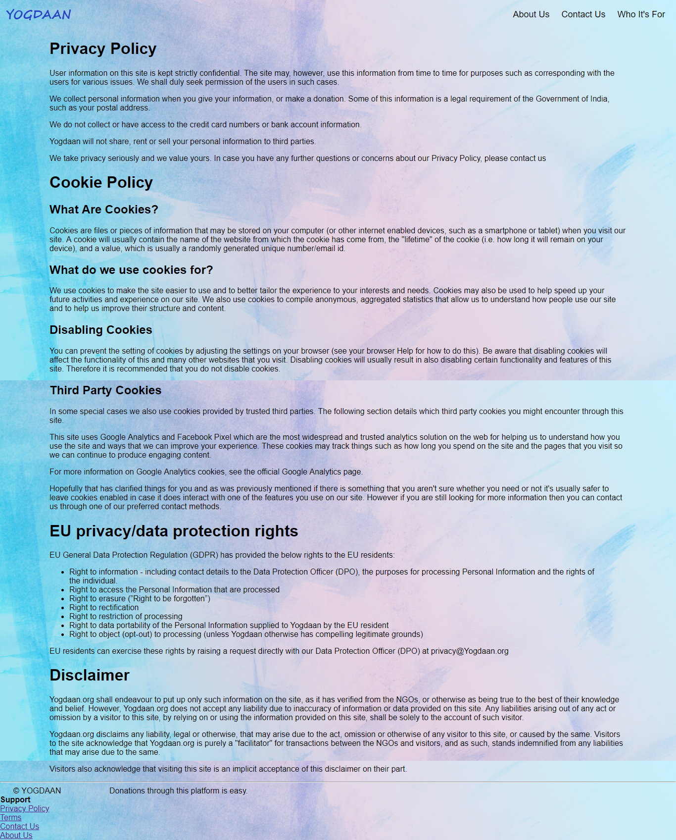

<html>

<head>

<style type="text/css">

* {

box-sizing: border-box;

}

body,

html {

height: 100%;

margin: 0;

font-family: Arial, Helvetica, sans-serif;

background-color: lightblue;

background-image: url("bg8.jpg");

}

.header {

overflow: hidden;

background-image: url("bg8.jpg");

/*background-color: lightblue;*/

padding: 5px 10px;

}

.header a {

float: left;

color: black;

text-align: center;

padding: 12px;

text-decoration: none;

font-size: 18px;

line-height: 25px;

border-radius: 4px;

}

.header a.logo {

font-size: 25px;

font-weight: bold;

background-image: url("yog.png");

background-repeat: no-repeat;

width: 140px;

/*background-size: cover;*/

background-position: center;

}

.header a:hover {

background-color: black;

color: white;

}

.header a.active {

background-color: black;

color: white;

}

.header-right {

float: right;

}

.terms {

padding-left: 100px;

padding-right: 100px;

}

.unordered {

padding-left: 40px;

padding-right: 40px;

}

.link {

text-decoration: none;

padding-right: 30px;

}

</style>

</head>

<body>

<div class="header">

<a href="WEB PAGE.html" class="logo"> </a>

<div class="header-right">

<a href="about us.html">About Us</a>

<a href=" Feedback.html"> Feedback </a>

<a href="who its for.html">Who It's For</a>

</div>

</div>

<!-- <hr> -->

<div class="terms">

<h1>Privacy Policy</h1>

<p>User information on this site is kept strictly confidential. The site may, however, use this information from time to time for purposes such as corresponding with the users for various issues. We shall duly seek permission of the users in such cases.</p>

<p>We collect personal information when you give your information, or make a donation. Some of this information is a legal requirement of the Government of India, such as your postal address.</p>

<p>We do not collect or have access to the credit card numbers or bank account information.</p>

<p>Yogdaan will not share, rent or sell your personal information to third parties.</p>

<p>We take privacy seriously and we value yours. In case you have any further questions or concerns about our Privacy Policy, please contact us</p>

<h1>Cookie Policy</h1>

<h2>What Are Cookies?</h2>

<p>Cookies are files or pieces of information that may be stored on your computer (or other internet enabled devices, such as a smartphone or tablet) when you visit our site. A cookie will usually contain the name of the website from which the cookie has come from, the "lifetime" of the cookie (i.e. how long it will remain on your device), and a value, which is usually a randomly generated unique number/email id.</p>

<h2>What do we use cookies for?</h2>

<p>We use cookies to make the site easier to use and to better tailor the experience to your interests and needs. Cookies may also be used to help speed up your future activities and experience on our site. We also use cookies to compile anonymous, aggregated statistics that allow us to understand how people use our site and to help us improve their structure and content.</h2>

<h2>Disabling Cookies</h2>

<p>You can prevent the setting of cookies by adjusting the settings on your browser (see your browser Help for how to do this). Be aware that disabling cookies will affect the functionality of this and many other websites that you visit. Disabling cookies will usually result in also disabling certain functionality and features of this site. Therefore it is recommended that you do not disable cookies.</p>

<h2>Third Party Cookies</h2>

<p>In some special cases we also use cookies provided by trusted third parties. The following section details which third party cookies you might encounter through this site.</p>

<p>This site uses Google Analytics and Facebook Pixel which are the most widespread and trusted analytics solution on the web for helping us to understand how you use the site and ways that we can improve your experience. These cookies may track things such as how long you spend on the site and the pages that you visit so we can continue to produce engaging content.</p>

<p>For more information on Google Analytics cookies, see the official Google Analytics page.</p>

<p>Hopefully that has clarified things for you and as was previously mentioned if there is something that you aren't sure whether you need or not it's usually safer to leave cookies enabled in case it does interact with one of the features you use on our site. However if you are still looking for more information then you can contact us through one of our preferred contact methods.</p>

<h1>EU privacy/data protection rights</h1>

<p>EU General Data Protection Regulation (GDPR) has provided the below rights to the EU residents:</p>

<ul class="unordered">

<li>Right to information - including contact details to the Data Protection Officer (DPO), the purposes for processing Personal Information and the rights of the individual.</li>

<li>Right to access the Personal Information that are processed</li>

<li>Right to erasure (”Right to be forgotten”)

<li>Right to rectification</li>

<li>Right to restriction of processing</li>

<li>Right to data portability of the Personal Information supplied to Yogdaan by the EU resident</li>

<li>Right to object (opt-out) to processing (unless Yogdaan otherwise has compelling legitimate grounds)</li>

</ul>

<p>EU residents can exercise these rights by raising a request directly with our Data Protection Officer (DPO) at privacy@Yogdaan.org</p>

<h1>Disclaimer</h1>

<p>Yogdaan.org shall endeavour to put up only such information on the site, as it has verified from the NGOs, or otherwise as being true to the best of their knowledge and belief. However, Yogdaan.org does not accept any liability due to inaccuracy of information or data provided on this site. Any liabilities arising out of any act or omission by a visitor to this site, by relying on or using the information provided on this site, shall be solely to the account of such visitor.</p>

<p>Yogdaan.org disclaims any liability, legal or otherwise, that may arise due to the act, omission or otherwise of any visitor to this site, or caused by the same. Visitors to the site acknowledge that Yogdaan.org is purely a "facilitator" for transactions between the NGOs and visitors, and as such, stands indemnified from any liabilities that may arise due to the same.</p>

<p>Visitors also acknowledge that visiting this site is an implicit acceptance of this disclaimer on their part.</p>

</div>

<hr>

<span style="padding-left:2%;padding-bottom:2%;">&copy; YOGDAAN &nbsp&nbsp&nbsp&nbsp&nbsp&nbsp&nbsp&nbsp&nbsp&nbsp&nbsp&nbsp&nbsp&nbsp&nbsp&nbsp&nbsp&nbsp&nbsp&nbsp&nbspDonations through this platform is easy.</span>

<br>

<b>Support</b>

<br>

<a href="privacy policy.html">Privacy Policy</a>

<br>

<a href="terms.html">Terms</a>

<br>

<a href=" Feedback.html"> Feedback </a>

<br>

<a href="about us.html">About Us</a>

<br>

<footer id="footer"></footer>

</body>

</html>

* **Terms & Conditions**

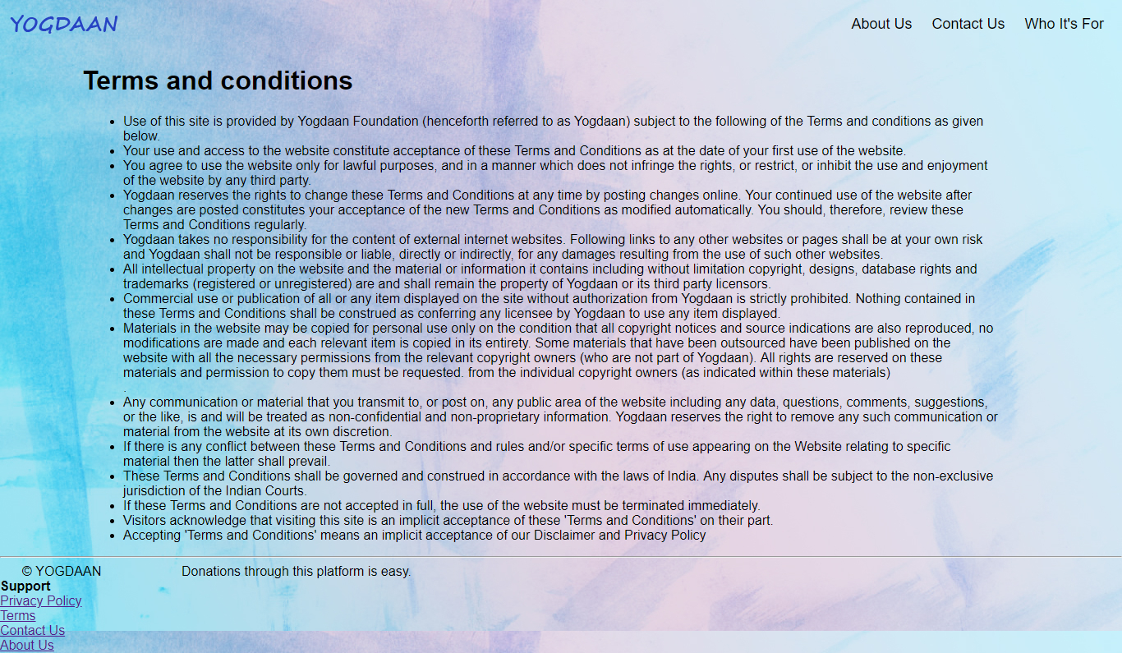

* Code:

<html>

<head>

<style type="text/css">

* {

box-sizing: border-box;

}

body,

html {

height: 100%;

margin: 0;

font-family: Arial, Helvetica, sans-serif;

background-color: lightblue;

background-image: url("bg8.jpg");

}

.header {

overflow: hidden;

background-image: url("bg8.jpg");

/*background-color: lightblue;*/

padding: 5px 10px;

}

.header a {

float: left;

color: black;

text-align: center;

padding: 12px;

text-decoration: none;

font-size: 18px;

line-height: 25px;

border-radius: 4px;

}

.header a.logo {

font-size: 25px;

font-weight: bold;

background-image: url("yog.png");

background-repeat: no-repeat;

width: 140px;

/*background-size: cover;*/

background-position: center;

}

.header a:hover {

background-color: black;

color: white;

}

.header a.active {

background-color: black;

color: white;

}

.header-right {

float: right;

}

.terms {

padding-left: 100px;

padding-right: 100px;

}

.unordered {

padding-left: 150px;

padding-right: 150px;

}

.link {

text-decoration: none;

padding-right: 30px;

}

</style>

</head>

<body>

<div class="header">

<a href="WEB PAGE.html" class="logo"> </a>

<div class="header-right">

<a href="about us.html">About Us</a>

<a href=" Feedback.html"> Feedback </a>

<a href="who its for.html">Who It's For</a>

</div>

</div>

<!-- <hr> -->

<h1 class="terms">Terms and conditions</h1>

<ul class="unordered">

<li>Use of this site is provided by Yogdaan Foundation (henceforth referred to as Yogdaan) subject to the following of the Terms and conditions as given below.</li>

<li>Your use and access to the website constitute acceptance of these Terms and Conditions as at the date of your first use of the website.</li>

<li>You agree to use the website only for lawful purposes, and in a manner which does not infringe the rights, or restrict, or inhibit the use and enjoyment of the website by any third party.</li>

<li>Yogdaan reserves the rights to change these Terms and Conditions at any time by posting changes online. Your continued use of the website after changes are posted constitutes your acceptance of the new Terms and Conditions as modified automatically. You should, therefore, review these Terms and Conditions regularly.</li>

<li>Yogdaan takes no responsibility for the content of external internet websites. Following links to any other websites or pages shall be at your own risk and Yogdaan shall not be responsible or liable, directly or indirectly, for any damages resulting from the use of such other websites.</li>

<li>All intellectual property on the website and the material or information it contains including without limitation copyright, designs, database rights and trademarks (registered or unregistered) are and shall remain the property of Yogdaan or its third party licensors.</li>

<li>Commercial use or publication of all or any item displayed on the site without authorization from Yogdaan is strictly prohibited. Nothing contained in these Terms and Conditions shall be construed as conferring any licensee by Yogdaan to use any item displayed.</li>

<li>Materials in the website may be copied for personal use only on the condition that all copyright notices and source indications are also reproduced, no modifications are made and each relevant item is copied in its entirety. Some materials that have been outsourced have been published on the website with all the necessary permissions from the relevant copyright owners (who are not part of Yogdaan). All rights are reserved on these materials and permission to copy them must be requested. from the individual copyright owners (as indicated within these materials)</li>.

<li>Any communication or material that you transmit to, or post on, any public area of the website including any data, questions, comments, suggestions, or the like, is and will be treated as non-confidential and non-proprietary information. Yogdaan reserves the right to remove any such communication or material from the website at its own discretion.</li>

<li>If there is any conflict between these Terms and Conditions and rules and/or specific terms of use appearing on the Website relating to specific material then the latter shall prevail.</li>

<li>These Terms and Conditions shall be governed and construed in accordance with the laws of India. Any disputes shall be subject to the non-exclusive jurisdiction of the Indian Courts.</li>

<li>If these Terms and Conditions are not accepted in full, the use of the website must be terminated immediately.</li>

<li>Visitors acknowledge that visiting this site is an implicit acceptance of these 'Terms and Conditions' on their part.</li>

<li>Accepting 'Terms and Conditions' means an implicit acceptance of our Disclaimer and Privacy Policy</li>

</ul>

<hr>

<span style="padding-left:2%;padding-bottom:2%;">&copy; YOGDAAN &nbspDonations through this platform is easy.</span>

<br>

<b>Support</b>

<br>

<a href="privacy policy.html">Privacy Policy</a>

<br>

<a href="terms.html">Terms</a>

<br>

<a href=" Feedback.html"> Feedback </a>

<br>

<a href="about us.html">About Us</a>

<br>

<footer id="footer"></footer>

</body>

</html>

* **Confirmation Animation**

Description**:**

In the end when the user is done with all the steps , the confirmation message and other things.

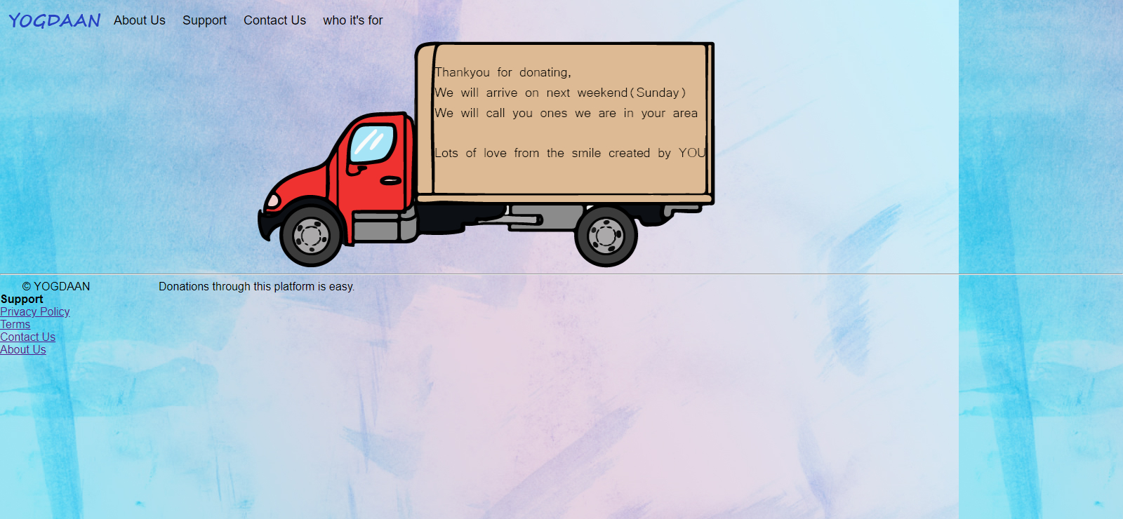

* Code**:**

<html>

<head>

<style type="text/css">

* {

box-sizing: border-box;

}

body,

html {

height: 100%;

margin: 0;

font-family: Arial, Helvetica, sans-serif;

background-color: lightblue;

background-image: url("bg8.jpg");

}

.header {

overflow: hidden;

background-image: url("bg8.jpg");

/*background-color: lightblue;*/

padding: 5px 10px;

}

.header a {

float: left;

color: black;

text-align: center;

padding: 12px;

text-decoration: none;

font-size: 18px;

line-height: 25px;

border-radius: 4px;

}

.header a.logo {

font-size: 25px;

font-weight: bold;

background-image: url("yog.png");

background-repeat: no-repeat;

width: 140px;

/*background-size: cover;*/

background-position: center;

}

.header a:hover {

background-color: black;

color: white;

}

.header a.active {

background-color: black;

color: white;

}

.header-right {

float: right;

}

.terms {

padding-left: 100px;

padding-right: 100px;

}

.unordered {

padding-left: 150px;

padding-right: 150px;

}

.link {

text-decoration: none;

padding-right: 30px;

}

</style>

</head>

<body>

<div class="header">

<a href="WEB PAGE.html" class="logo"> </a>

<a href="about us.html">About Us</a>

<a href="#footer">Support</a>

<a href=" Feedback.html"> Feedback </a>

<a href="who it's for">Who it's for</a>

<div class="header-right">

</div>

</div>

<marquee><img src="truck2.png"></marquee>

<hr>

<span style="padding-left:2%;padding-bottom:2%;">&copy; YOGDAAN &nbsp&nbsp&nbsp&nbsp&nbsp&nbsp&nbsp&nbsp&nbsp&nbsp&nbsp&nbsp&nbsp&nbsp&nbsp&nbsp&nbsp&nbsp&nbsp&nbsp&nbspDonations through this platform is easy.</span>

<br>

<b>Support</b>

<br>

<a href="privacy policy.html">Privacy Policy</a>

<br>

<a href="terms.html">Terms</a>

<br>

<a href=" Feedback.html"> Feedback </a>

<br>

<a href="about us.html">About Us</a>

<br>

<footer id="footer"></footer>

</body>

</html>

* **Get Started**

Description:

In this we take information from user his address and all other details.

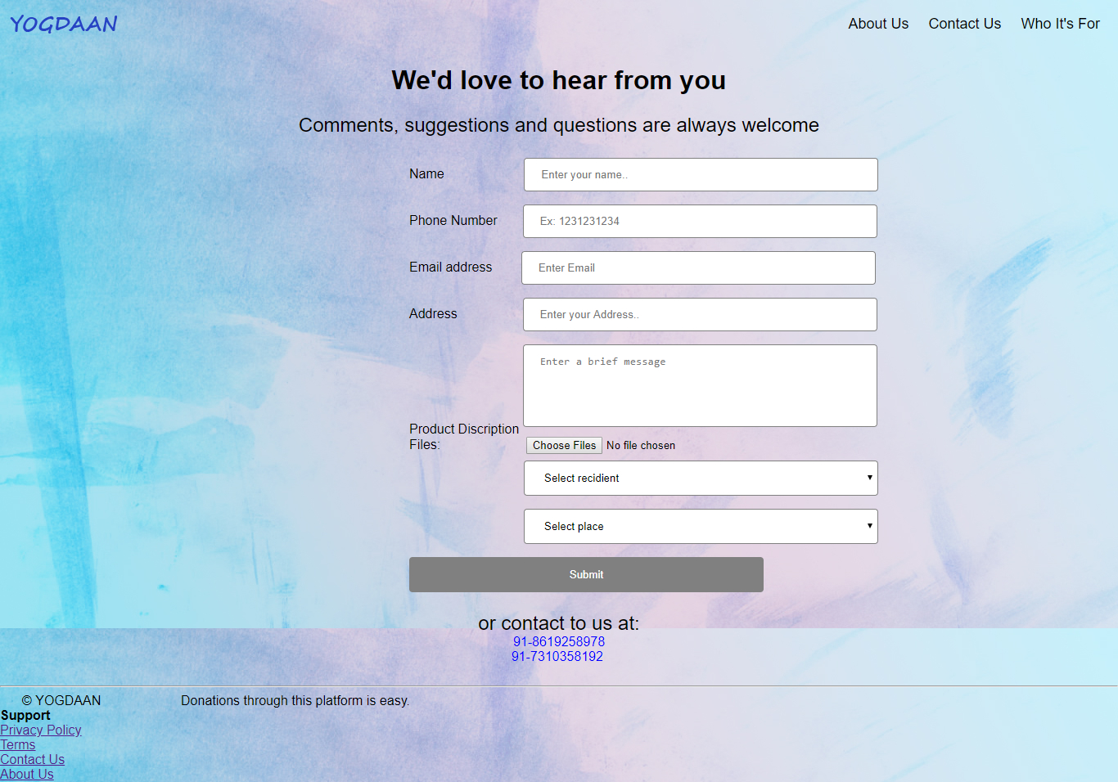

* **Code**

<html>

<head>

<style type="text/css">

* {

box-sizing: border-box;

}

body,

html {

height: 100%;

margin: 0;

font-family: Arial, Helvetica, sans-serif;

background-color: lightblue;

background-image: url("bg8.jpg");

}

.header {

overflow: hidden;

background-image: url("bg8.jpg");

/*background-color: lightblue;*/

padding: 5px 10px;

}

.header a {

float: left;

color: black;

text-align: center;

padding: 12px;

text-decoration: none;

font-size: 18px;

line-height: 25px;

border-radius: 4px;

}

.header a.logo {

font-size: 25px;

font-weight: bold;

background-image: url("yog.png");

background-repeat: no-repeat;

width: 140px;

/*background-size: cover;*/

background-position: center;

}

.header a:hover {

background-color: black;

color: white;

}

.header a.active {

background-color: black;

color: white;

}

.header-right {

float: right;

}

.inps {

width: 50%;

background-color: grey;

color: white;

padding: 14px 20px;

margin: 8px 0;

border: none;

border-radius: 4px;

cursor: pointer;

}

.inp {

width: 50%;

padding: 12px 20px;

margin: 8px 0;

display: inline-block;

border: 1px solid grey;

border-radius: 4px;

box-sizing: border-box;

resize: none;

}

.mrg {

text-align: left;

margin-left: 500px;

}

.mrg2 {

text-align: left;

margin-left: 100px;

}

.mrg3 {

text-align: left;

margin-left: 140px;

}

input[type=submit]:hover {

background-color: grey;

}

.header-center {

text-align: center;

}

.link {

text-decoration: none;

padding-right: 30px;

}

</style>

</head>

<body>

<div class="header">

<a href="WEB PAGE.html" class="logo"> </a>

<div class="header-right">

<a href="about us.html">About Us</a>

<a href="Feedback.html"> Feedback </a>

<a href="who its for.html">Who It's For</a>

</div>

</div>

<div class="header-center">

<h1>We'd love to hear from you</h1>

<font size="5">Comments, suggestions and questions are always welcome</font>

<br>

<br>

<form class="mrg">

<div class="form-group">

<label for="contact-name">Name &nbsp &nbsp &nbsp &nbsp &nbsp &nbsp &nbsp &nbsp&nbsp&nbsp&nbsp&nbsp&nbsp</label>

<input type="text" class="form-control inp" id="contact-name" name="name" placeholder="Enter your name.." onkeyup='validateName()'>

<span class='error-message' id='name-error'></span>

</div>

<div class="form-group">

<label for="contact-phone">Phone Number&nbsp&nbsp&nbsp&nbsp&nbsp&nbsp</label>

<input type="tel" class="form-control inp" id="contact-phone" name="phone" placeholder="Ex: 1231231234" onkeyup='validatePhone()'>

<span class='error-message' id='phone-error'></span>

</div>

<div class="form-group">

<label for="contact-email">Email address&nbsp&nbsp&nbsp&nbsp&nbsp&nbsp&nbsp</label>

<input type="email" class="form-control inp" id="contact-email" name="email" placeholder="Enter Email" onkeyup='validateEmail()'>

<span class='error-message' id='email-error'></span>

</div>

<div class="form-group">

<label for="contact-add">Address &nbsp &nbsp &nbsp &nbsp &nbsp &nbsp &nbsp &nbsp&nbsp</label>

<input type="text" class="form-control inp" id="contact-add" name="add" placeholder="Enter your Address.." onkeyup='validateadd()'>

<span class='error-message' id='add-error'></span>

</div>

<div class="form-group">

<label for='contactMessage'>Product Discription</label>

<textarea class="form-control inp" rows="5" id='contact-message' name='message' placeholder="Enter a brief message" onkeyup='validateMessage()'></textarea>

<span class='error-message' id='message-error'></span>

</div>

Files:

<input type="file" class="mrg2" id="files" name="files" multiple accept="image/*">

<br/>

<div id="selectedFiles"></div>

<select id="recidient" onchange="update()" class="inp mrg3">

<option selected="selected">Select recidient</option>

<option value="1">Orphan_Age</option>

<option value="2">Old_Age</option>

</select>

<select id="place" class="inp mrg3">

<option selected="selected">Select place</option>

</select>

<button onclick='validateForm()' class="btn btn-default inps">Submit</button>

<span class='error-message' id='submit-error'></span>

</form>

<font size="5">or contact to us at:<br></font>

<font color="blue">91-8619258978</font>

<br>

<font color="blue"> 91-7310358192</font>

<br>

<br>

</div>

<script type="text/javascript">

function validateName() {

var name = document.getElementById('contact-name').value;

if (name.length == 0) {

producePrompt('Name is required', 'name-error', 'red')

return false;

}

if (!name.match(/^[A-Za-z]*\s{1}[A-Za-z]*$/)) {

producePrompt('First and last name, please.', 'name-error', 'red');

return false;

}

producePrompt('Valid', 'name-error', 'green');

return true;

}

function validateadd() {

var add = document.getElementById('contact-add').value;

if (add.length == 0) {

producePrompt('Address is required', 'add-error', 'red')

return false;

}

if (!add.match(/^[A-Za-z]*\s{1}[A-Za-z]*$/)) {

producePrompt('Valid address, please.', 'add-error', 'red');

return false;

}

producePrompt('Valid', 'add-error', 'green');

return true;

}

function validatePhone() {

var phone = document.getElementById('contact-phone').value;

if (phone.length == 0) {

producePrompt('Phone number is required.', 'phone-error', 'red');

return false;

}

if (phone.length != 10) {

producePrompt('Not Valid.', 'phone-error', 'red');

return false;

}

if (!phone.match(/^[0-9]{10}$/)) {

producePrompt('Only digits, please.', 'phone-error', 'red');

return false;

}

producePrompt('Valid', 'phone-error', 'green');

return true;

}

function validateEmail() {

var email = document.getElementById('contact-email').value;

if (email.length == 0) {

producePrompt('Email Invalid', 'email-error', 'red');

return false;

}

if (!email.match(/^\w+([\.-]?\w+)*\w+([\.-]?)@\w+([\.-]?\w+)*(\.\w{2,3})+$/)) {

producePrompt('Email Invalid', 'email-error', 'red');

return false;

}

producePrompt('Valid', 'email-error', 'green');

return true;

}

function validateMessage() {

var message = document.getElementById('contact-message').value;

var required = 30;

var left = required - message.length;

if (left > 0) {

producePrompt(left + ' more characters required', 'message-error', 'red');

return false;

}

producePrompt('Valid', 'message-error', 'green');

return true;

}

function validateForm() {

if (!validateName() || !validatePhone() || !validateEmail() || !validateMessage() || !validateadd()) {

jsShow('submit-error');

producePrompt('Please fix errors to submit.', 'submit-error', 'red');

setTimeout(function() {

jsHide('submit-error');

}, 2000);

} else {

href(confirmationAnimation.html);

}

}

function jsShow(id) {

document.getElementById(id).style.display = 'block';

}

function jsHide(id) {

document.getElementById(id).style.display = 'none';

}

function producePrompt(message, promptLocation, color) {

document.getElementById(promptLocation).innerHTML = message;

document.getElementById(promptLocation).style.color = color;

}

</script>

<script>

var selDiv = "";

document.addEventListener("DOMContentLoaded", init, false);

function init() {

document.querySelector('#files').addEventListener('change', handleFileSelect, false);

selDiv = document.querySelector("#selectedFiles");

}

function handleFileSelect(e) {

if (!e.target.files || !window.FileReader) return;

selDiv.innerHTML = "";

var files = e.target.files;

var filesArr = Array.prototype.slice.call(files);

filesArr.forEach(function(f) {

var f = files[i];

if (!f.type.match("image.*")) {

return;

}

var reader = new FileReader();

reader.onload = function(e) {

var html = "<img src=\"" + e.target.result + "\">" + f.name + "<br clear=\"left\"/>";

selDiv.innerHTML += html;

}

reader.readAsDataURL(f);

});

}

</script>

<hr>

<span style="padding-left:2%;padding-bottom:2%;">&copy; YOGDAAN &nbsp&nbsp&nbsp&nbsp&nbsp&nbsp&nbsp&nbsp&nbsp&nbsp&nbsp&nbsp&nbsp&nbsp&nbsp&nbsp&nbsp&nbsp&nbsp&nbsp&nbspDonations through this platform is easy.</span>

<br>

<b>Support</b>

<br>

<a href="privacy policy.html">Privacy Policy</a>

<br>

<a href="terms.html">Terms</a>

<br>

<a href=" Feedback.html"> Feedback </a>

<br>

<a href="about us.html">About Us</a>

<br>

<footer id="footer"></footer>

<script type="text/javascript">

function update() {

var Orphan_Age = ["Dayanand Bal Sadan", "I-India", "S O S Children`s Village", "Shanti Bhavan"];

var Old_Age = ["Navachaitanya", "Guru Vishram Vridh Ashram", "Anandashram", "Helpage Elders Village"];

var recidients = document.getElementById("recidient");

var plc = document.getElementById("place");

var selected = recidients.value;

var html = '<option selected="selected">Select place</option>';

if (selected === "1") {

for (var i = 0; i < Orphan_Age.length; i++) {

html += '<option value="' + Orphan_Age[i] + '">' + Orphan_Age[i] + '</option>';

}

} else if (selected === "2") {

for (var j = 0; j < Old_Age.length; j++) {

html += '<option value="' + Old_Age[j] + '">' + Old_Age[j] + '</option>';

}

}

plc.innerHTML = html;

}

</script>

</body>

</html>

**SCOPE FOR FURTHER DEVELOPMENT**

This website can be further developed by attaching it to database technologies and fetching all the values dynamically through DBMS.

This is a static website and to enhance the functionality to a much better extent it must be dynamic and properly working will all the functionalities.

**BIBLIOGRAPHY**

* http://www.nishkam.in/donations
* https://health.usnews.com/wellness/aging-well/articles.com
* http://www.depthnheight.com/category/childhood
* https://www.impactguru.com/fundraiser/orphanage--old-age